Git Workflow for Smart Security Systems Project

The proposal here is to have a framework which is adapted from the Gitflow workflow. This document proceeds, assuming that the basic Git structure is known to the reader and is already familiar with Git concepts such as branches, pushes, commits, etc.

The concept is to have separate branches for developing various independent subsystems within the main project. For instance, consider the project has separate subsystems such as Android development, Sensor interfacing with Arduino, Web Application design, etc. The concept is to assign the tasks involved in the development of these subsystems to a particular branch called as feature branch in the Git flow.
The terminology of the various branches in the workflow is next explained:

master branch
The always stable branch in the project. The various commits on the master branch are usually tagged with release versions like v0.0, v0.1, etc. The access to pushing into master branch should reside only with the admin community. The code in the master should always be in a position to be successfully compiled without errors, and warnings. Also, the master branch should contain all the necessary documentation on a user level as this is the means for interaction with members not part of the project. All code standard guidelines are to be met and verification, validation processes to be completed and proof of the tests be displayed. (this could be in the form of an exe, other binaries, logs of test code, etc.)

develop branch
The develop branch serves as an integration branch. All developers to checkout the contents of this branch before they work on their respective features. After they have completed their work, the modifications are to be integrated into the develop branch.

Here, consider the creation of an optional new branch called release branch. So, if sufficient features are developed and integrated into the develop branch, then there needs to be a new branch called release which would eventually lead to the final release version to be pushed into master. No new features can be added to the release branches. It is mainly intended for documentation and some bug fixes to the code if absolutely needed. Regression tests to be performed before the release branch is created from develop.

feature branch
Each new feature should reside in its own branch, which can be pushed to the central repository for backup/collaboration. But, instead of branching off of master, feature branches use develop as their parent branch. When a feature is complete, it gets merged back into develop. Features should never interact directly with master.

A picture depicting the above mentioned workflow is show next. Master contains the stable version, develop branches off from master and all feature branches come from develop as parent. The feature branches then merge into develop. Bug fixes done on release branches before the release is made public through the master branch commit. A system of integrating all the feature branches with develop branch could be done every Friday by an Integrator.
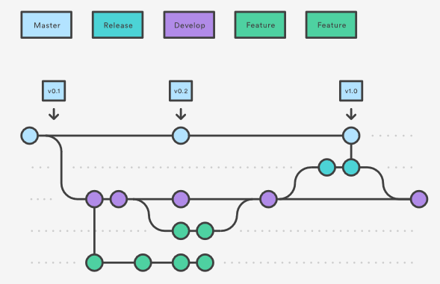

After a particular feature has reached the end of its life cycle, it is possible to validate the feature, perform regression tests, documentation and then delete the feature branch.

Also, a terminology with respect to the branch names is needed. The proposal is as follows. It could be possible to derive it from an issue number at least for the feature branches, but if there are inconsistencies to the issue numbers, then it is necessary to think of other means to achieve the objective.

For master, develop and release branches it could be as follows:

- origin/master/
- origin/develop/
- origin/release/

For feature branches,

origin/feature/Issue_Number-<small_description_of_feature>

